**What is the difference between a registered database and a managed database?**

Last Published: October 8, 2020

**Answer**

When registering databases as data stores in ArcGIS Server Manager, the database can be registered as a registered database or managed database.

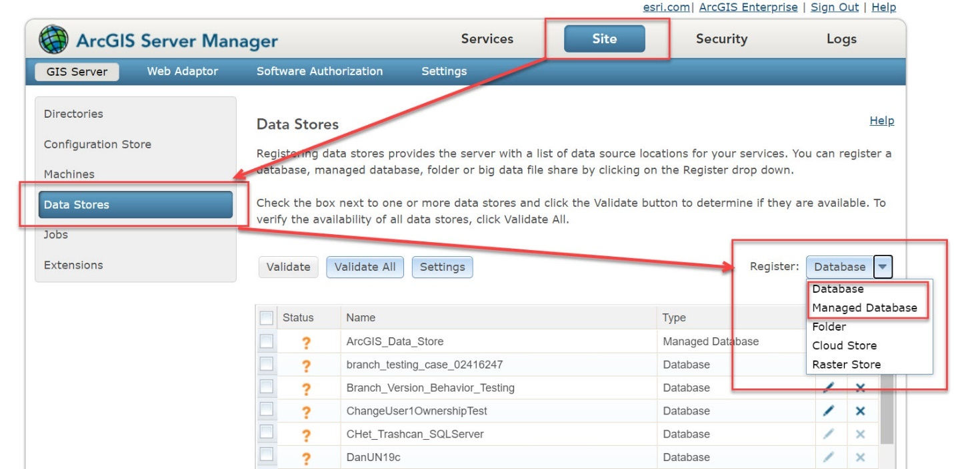

The basic difference between a registered database and a managed database is the location where the data is stored when publishing a feature or feature service.

When publishing from a registered database, the data remains in the database and is simply referenced in the location.

A registered database is recommended in the following scenarios:

* When publishing a service type other than a feature or transactional web feature service (WFS-T)
* If the data resides in an enterprise geodatabase
* When publishing database tables accessed through an OLE DB connection file (.odc)
* When synchronizing changes between the publisher’s machine and ArcGIS Server’s managed database

A registered database is typically used in SQL Server, Oracle, or PostgreSQL databases registered with ArcGIS Server.

On the other hand, a managed database copies data to the database when publishing a feature or feature service. Copying data when publishing is useful for web services to access the source data when the data is behind a firewall but the web services are not.

A managed database is recommended in the following scenarios:

* When publishing data from a location that is not an enterprise geodatabase, such as a file geodatabase, or a shapefile
* When publishing data from a location that is not registered as a data store.
* When publishing feature services or WFS-T services

A managed registered database is more relevant while publishing a feature or web feature service (WFS). The managed database can only be used with feature or WFS-T services, along with any capabilities concurrently published with these service types. If the ArcGIS Server site has a managed database and a feature service or a WFS-T service is published, data is copied to the managed database.

**Note**:

If the service type being published requires an enterprise geodatabase, first create an enterprise geodatabase, and register it as ArcGIS Server's managed database.

Multiple databases can be registered, while only one enterprise database can be registered as a managed database.

A registered database means that you have data in SQL Server, Oracle, PostGres, etc and that database is registered with your ArcGIS Server.  When you publish from that database, the data stays in the database and is simply referenced in that location:

[About registering your data with ArcGIS Server—Documentation | ArcGIS Enterprise](http://server.arcgis.com/en/server/latest/publish-services/windows/overview-register-data-with-arcgis-server.htm#ESRI_SECTION1_015C666026144A7CBD9C17FD501F28FD)

A managed registered database is more relevant for feature services.  The publishing process will use a managed registered database in the following scenarios:

* you're publishing data from a location that isn't an enterprise geodatabase, (file geodatabase, shapefile)
* You're publishing data from a location that isn't registered as a data store

[Copying data to the server automatically when publishing—Documentation | ArcGIS Enterprise](http://server.arcgis.com/en/server/latest/publish-services/windows/copying-data-to-the-server-automatically-when-publishing.htm)

If you're using GeoEvent, you're likely going to want to use the [spatiotemporal ArcGIS Data Store](http://server.arcgis.com/en/geoevent/latest/administer/managing-big-data-stores.htm).

If you're wondering about the registration options in ArcGIS Server Manager specifically, registering a managed database here means you provide and maintain an enterprise geodatabase into which data will be copied when you publish a feature service to that stand-alone ArcGIS Server site.  (In ArcGIS Pro, you need to choose the Copy data option when publishing.)

Publishing to an ArcGIS Server site that has a managed database that you provide is a narrow use case.  A managed database is useful when you need to get on-premises data into a geodatabase in the cloud or outside your firewall. When you publish a feature service to an ArcGIS Server site that has a managed database, the data is copied from the source into the managed database. The service accesses the data that was copied to the managed database, not the source data.

Registering a database with the ArcGIS Server site is a far more common workflow. You would do this any time you want the services on your ArcGIS Server site (stand-alone or federated) to access the source data in your enterprise geodatabase or database. The data stays in this database and is not copied when you publish. (In ArcGIS Pro, you need to choose to reference registered data when you publish.) That means people who work with the data through a database connection and those who access the published services are working with the same data.

<https://community.esri.com/t5/arcgis-enterprise-questions/about-managed-database-in-server/td-p/241655>